87056961897
821204401067

ӨТЕУОВА Көркем,
М.Шоқай атындағы білім беретін мектебінің ағылшын тілі пәні мұғалімі.
Түркістан қаласы

MY COUNTRY. READING FOR PLEASURE. ABAY QUNANBAYULI.

Learning objectives | 9.C1 use speaking and listening skills to solve problems creatively and cooperatively in groups  9.R5 deduce meaning from context in short texts on a limited range of familiar general and curricular topics
Lesson objectives | All learners will be able to: • Identify the theme, new words and use them as the basis for discussion. • Read a text about Abai Qunanbaiuli.  Most learners will be able to:  • Select, compile, and synthesize information for an oral presentation • speak about a great Kazakh poet.  • Learn compound nouns.  Some learners will be able to:• Respond to and discuss the reading  passage using interpretive, evaluative and creative thinking skills.  Write a paragraph about a Kazakh writer.
Plan

Stages/  Time | Teachers’ actions | Students’ actions | Assessment criteria | Resources
Start    5 min  7 min | 1.Greeting.  Teacher greets students.  Good morning!  How are you?  Welcom to our English lesson.  Warm-up  • Method ‘The wish flower’ helps to start the lesson with good wishes to each other.  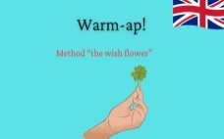  Checking up hometask.  Teacher checks the home task and  intraduces the aim and theme of the lesson. Puzzle pieces | The aim: To develop Ss speaking skills and create friendly atmosphere  Efficiency: By telling the wishes they show their appreciations.  Ss Find the genres with photo.  Pupils look at the pictures and guess what we are going to talk about today? | At the organization moment T tries to award active Ss.  «The praise» method is used to evaluate Ss with phrases like:  “Good job!  Well done!”    Good job! | PPT  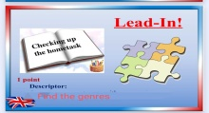  https://learningapps.org/userapps.php?user=10229917
Main part  5 min    5 min    Video  2 min  10min | Тeacher sets the lesson objectives, letting students know what to anticipate from the lesson.  Pre-teaching task.  Method ‘Think and find’  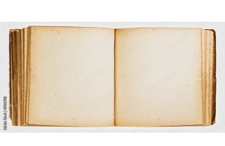  Students guess the poem and their authors.  Students, today we will talk about writers and their poems.  New words.  Religious-  Local-  Head of-  Wise-  Spiritual-  Techer shows the video about the Abay Kunanbayuli  Reading task  Ask students to read the text with method ‘ Green light, red light’ when Tt says green light Ss start reading and Tt says red light students stop reading.  Ex:1 P:64  • Draw students’ attention to the photo.  • Ask who the statue is of to elicit Abai Qunanbaiuli.  • Put students in small groups to discuss what they know about him and what his most famous book is.  • Ask students if they have ever read any of the book or if they know what it is about  Differentiation:  «Verbal support» method is used to help Students use new words in the text.  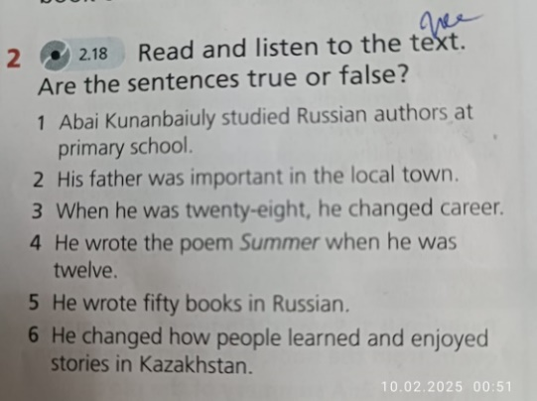  Ex: 3 P:64  • Game ‘Asyk’  Tt invited Ss for playing game ‘Asyk’  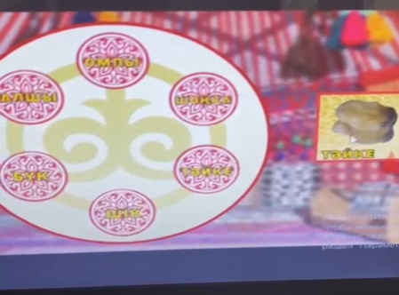  Ex:4 P:64  • Draw students’ attention to the words.  • Ask them what other compounds they have seen in the unit.  • Students work individually to find the compounds in the text | Students find the author by answering the question  Ss write and repeat the new words and learn them by heart.  Ss watch the video  And try to get it  Students read the text correctly with method ‘ Green light, red light’ when Tt says green light  Ss start reading and Tt says red light students stop reading.  Students discuss about Kazakh great poet.  Students read and listen to the text. Are the sentences true or false?  Students look at the text to find the other half of the compound nouns  ANSWERS:  1 school 2 literature 3 community 4 the family 5 man 6 leader | Descriptor:  - read the poem and find the author  Teacher prises active students with phrases such as:  Good job!  Well down!  Teacher prises active students with phrases such as:  Good job!  Well down!  Teacher prises active students with phrases such as:  Good job!  Well  Descriptor:  - read and listen to the text. Are the sentences true or false?  Descriptor:  answer the questions correctly.  Assessment criteria:  - Learn compound nouns.  Descriptor:  - look at the text to find the other half of the compound nouns | Smartboard  https://heyzine.com/flip-book/6ce85f5ecb.html  Video I  Student’s book  Student’s book  Smartbord  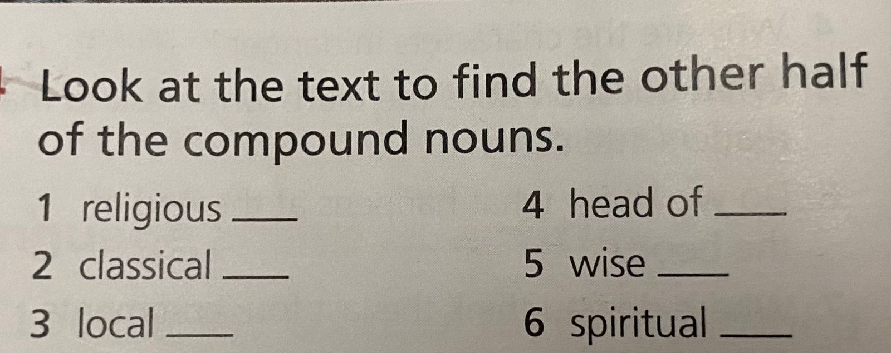
End | Giving the hometask.  Read the text | Assessment. Traffic light.  Feedback. The teacher gives comments about learners work and awards learner. Students will choose one and put on the board their stickers. | Students use their stickers to show their knowledge according to the lesson. | 